An Improved Discrete Crow Search Algorithm for Influence Maximization

1st Neeraj Bhatt
Department of Computer Science
University of Delhi
(of Affiliation)
New Delhi, India
neerajb.msc25@cs.du.ac.in
2nd Manish Kumar
Department of Computer Science
University of Delhi
(of Affiliation)
New Delhi, India
manishk.msc25@cs.du.ac.in

Abstract— The problem of maximizing influence (IM) in the context of social network analysis involves determining a set of seed nodes that can generate the largest amount of information or behavior through an actual diffusion process, and is considered one of the fundamental applications of social network analysis. Although using the Discrete Crow Search Algorithm (DCSA) provides an effective metaheuristic framework for solving this problem, its current form does not utilize methods to support diversity among selected seeds as well as utilizing an overly simplistic method to estimate influence, which can lead to overfitting solutions that are too close to the hubs in the network. This paper enhances DCSA by providing two aspects of evolution to the algorithm. The first of these, referred to as IC, incorporates a penalty in the fitness function for the distance between seed nodes. This helps to prevent placing seeds too close together and increases the diversity among the locations where they are placed. Similarly, the second enhancement, IC_Spread, combines three additional elements into the original DCSA to improve the quality of the solution, while also increasing the robustness of the convergence process: (1) a probabilistic two-hop estimate of influence, (2) the ability to adaptively handle stagnation during a run, and (3) a lightweight local search process during the run. The results of 3 extensive experiments captured from 3 different co-authorship networks (HepTh, CondMat, CaAstroPh) demonstrate that the IC_Spread method consistently achieves greater levels of influence than DCSA, as well as achieving results that are comparable to or exceed those of CELF and DPSO methods for K = {10, 20, 30, 40, 50} when using the seed set. In addition to demonstrating the usefulness of adding elements designed to promote diversity, our work emphasizes the value of enhancing methods for estimating influence in creating metaheuristic methods for solving the IM problem.
Keywords—influence maximization, top seed set selection, social networks, discrete crow search algorithm, metaheuristic optimization, independent cascade model, distance penalty

Introduction
The rise of online social media has changed the focus of research on how information spreads, making the study of it a significant area of interest in both computational social science and data mining. A central research question in this area is influence maximization (IM); given a social graph G = (V, E), we want to determine which k nodes in V to activate (i.e., seed nodes) so as to maximize the expected number of nodes that are activated via a specified propagation model [1]. Kempe et al. [2] introduced a formal optimization algorithm for IM, demonstrating that IM is NP-hard. They also provided a greedy algorithm to approximate the solution with a performance guarantee of (1 - 1/e) when using submodular influence functions (e.g., the Independent Cascade (IC) model). The main drawback of the greedy approximation approach is that it relies on Monte Carlo simulations for estimating influence; consequently, greedy approaches become computationally infeasible as the size of the network grows. Therefore, researchers have explored a wealth of potential solutions to IM, including scalable heuristics, lazy evaluation methods (e.g., CELF [3]) and most recently, metaheuristic algorithms such as Discrete Particle Swarm Optimization (DPSO) [4], Genetic Algorithms and Simulated Annealing. The DCSA [5] is based on the continuous form of the Crow Search Algorithm and provides an flexible, swarm-based method for solving combinatorial optimization problems and has demonstrated competitive performance on benchmarks for IM. However, the original DCSA suffers from several limitations.

Related work
The work of Kempe and colleagues [2] first framed influence maximization as a submodular optimization problem, leading to the establishment of the greedy algorithm as the theoretical benchmark for this problem. The main practical difficulty in applying this theorem was that each node evaluation required O(n) Monte Carlo evaluations. This was somewhat mitigated by Leskovec and colleagues [3] when they presented the Cost-Effective Lazy Forward (CELF) selection method by leveraging submodularity to eliminate redundant node evaluations, resulting in vastly reduced run times while maintaining the provably accurate approximation to the influence maximization solution. Building on this, Goyal and associates formed CELF++ [6] that further reduced oracle calls by recording marginal expectation histories.

Moreover, there has been parallel research into heuristic approaches that model node influence propagation. Degree Discount [7] uses an adjusted degree heuristic to estimate the best seed choices, providing O(n) computational efficiency at the expense of optimality. Community-based heuristics [8] use community structures in the graph to best distribute seed nodes throughout the entire graph. High-dimensional graph embeddings have also been utilized for seed selection [9].

Metaheuristics have become popular as a solution to escape local optima when there is no need to leverage submodularity. Particle Swarm Optimization adapted to discrete measures [4] relates seed sets as binary vectors and updates velocities based on personal best and global best solutions. Genetic algorithms [10] employ crossover and mutation methodologies to operate on populations of seed sets. Originally proposed in 2009 by Askarzadeh [11], the Crow Search Algorithm.

Methodology
We suggest the following improvements to develop DCSA‛s capacity for maximising influence. Not only will these improvements address the core limitations of DCSA, but they will also enhance the overall performance of DCSA. These limitations include inaccurate multi-hop influence estimates, early convergence during the optimisation process and re-computed fitness values unnecessarily. Our improvements will both enhance the quality of the influence estimation process as well as optimise the efficiency of the search process using DCSA while retaining the original discrete crow search algorithm structure..

Problem Formulation
Let G = (V, E) be a directed or undirected social network graph where the number of nodes is n = | V | and the number of edges is m = | E | . Under the Independent Cascade (IC) model of diffusion, for any edge (u, v ) ∈ E there exists a probability p(u,v ) that an edge will activate the next node; all of which will occur through a series of diffusion steps based on one or more initial seed nodes, S ⊆ V . During the diffusion process each activated node attempts to activate its neighbouring nodes independently from one another with the same activation probability; in the following diffusion step, they will make another attempt at activating those nodes. The influence of S is measured by σ(S) — that is, the expected number of activated nodes when no further diffusion can occur.
The influence maximising (IM) problem can therefore be formally stated as:

$$S^{}=arg\max_{S⊆V,\left|S\right|=k}σ\left(S\right)$$

where k is the maximum number of seeds that can be used. Due to the fact that σ(S) is #P-hard and cannot be computed exactly, practical metaheuristic methods, as shown through enhanced DCSA, utilise surrogate influence estimation algorithms to provide computationally efficient approximations to the total number of activated nodes during the optimisation phase of the IM problem..

Original DCSA
DCSA represents all candidate solution seed sets as individual crows with position vector $X_{i}=\left[x_{i,1},…,x_{i,k}\right]$

among a total population of n. Therefore, each candidate solution encodes an individual crow has a seed set value of size k. Additionally, as part of the process, each candidate seed set has a corresponding memory vector ($M_{i}$) - the best seed set found by that individual during its search). When updating its position at each of the iterations, a crow refers to the crow with the randomly selected position from another individual (peer). For each seed component ($x_{i,j}$), if the corresponding node does not exist in the selected peers' memory (the flight criteria has been met), then from an available pool of pre-computed nodes of high value (i.e., quality) a seed component will be replaced by that of a candidate drawn at random. Alternatively, based on the awareness parameter AP, a candidate pool of nodes will be explored randomly by performing a walk through the available candidate pool to diversify the search process.

Influence Estimation Function which is developed by Gong et al. [39] to estimate the influence within the two-hop area of a given node set.
$$LIE\left(S\right)=σ_{0}\left(S\right)+σ_{1}^{}\left(S\right)+σ_{2}^{}\left(S\right)$$

The update rules redesigned in a discrete form for discrete crow search algorithm. The new evolutionary rules for DCSA is defined as:
$$x_{i,iter+1}←x_{i,iter}⊕H\left(r_{i}×{fl}_{i,iter}×\left(x_{i,iter}∩m_{j,iter}\right)\right)$$
Where ri is a random number. $x_{i,iter}$ and $x_{i,iter+1}$ are the position of crow $x_{i}$. ${fl}_{i,iter}$ is the flight length of crow $i$. $m_{j,iter}$ is the memory location of crow $j$. The operator “∩” in the formula is used to determine whether there is a common element between $x_{i,iter}$ and $m_{j,iter}$. If there is a node in $m_{j,iter}$ that is same as an element in $x_{i,iter}$, the element at the corresponding position in the result is set to 0, otherwise it is set to 1.
H (·) is a decesion function.
$$h_{j}\left(x_{ij}\right)=\left\{\begin{matrix}0 & ifx_{ij}<1 \\ 1 & ifx_{ij}≥1\end{matrix}\right.$$
The operator “⊕” is used to determine whether element $x_{ij}$ in $x_{i}$ should be retained or replaced. And the update rules is formulated as:
$$x_{ij,iter+1}=\left\{\begin{matrix}x_{ij,iter} & \text{if} h_{j}\left(x_{ij}\right)=0 \\ Replace\left(x_{ij,iter},V\right) & \text{if} h_{j}\left(x_{ij}\right)=1\end{matrix}\right.$$

The candidate pool uses a composite score to define the contribution of each node by combining two separate measures as defined below:

$$NC\left(v\right)=α\frac{ks\left(v\right)}{∑ks}+\left(1-α\right)\frac{1/C\left(v\right)}{∑\left(1/C\right)}$$
where ks(v) is the corresponding k-shell (coreness) value assigned to each node in the candidate pool, and C(v) is the structural constraint(Burt’s constraint) defined in [12]. An equal weight is assigned (with α= 0.5) to each value to create a final ranked candidate list from the top βk (default β = 3) used in [13].

Distance-Penalized Fitness
The IC version maintains the original LIE estimator, but also has an added structural distance penalty in its fitness function to discourage picking seeds that are too close together spatially. The idea being that seeds that are graphically close to one another often have overlapping influence neighborhoods; therefore, any resulting diffusion coverage will be redundant and very little additional value will be generated by selecting both of those seeds to initiate diffusion from.
To quantify this effect, we define pairwise proximity penalties over seed pairs $\left(u,w\right)∈S×S$ as:
$$pen_{d1}\left(S\right)=\frac{\left|\{\left(u,w\right):w∈N\left(u\right)\}\right|}{\left({k \atop 2}\right)}$$
$pen_{d2}\left(S\right)=\frac{\left|\{\left(u,w\right):N\left(u\right)∩N\left(w\right)≠∅\}\right|}{\left({k \atop 2}\right)}$
where $N\left(u\right)$ denotes the neighborhood of node $u$. The first term penalizes directly adjacent seed pairs, while the second captures two-hop neighborhood overlap. The aggregate penalty is defined as:
$$pen\left(S\right)=pen_{d1}\left(S\right)+0.1⋅pen_{d2}\left(S\right)$$
where the lower weighting on $pen_{d2}$ reflects the observation that limited two-hop overlap may still contribute positively to diffusion under the IC model.
The penalized fitness function is then formulated as:
$$F_{IC}\left(S\right)=LIE\left(S\right)⋅\left(1-γ⋅pen\left(S\right)\right)$$
To prevent over-penalization across networks with differing structural densities, the scaling factor $γ$ is adaptively calibrated for each graph. Specifically, $n_{sample}=30$ candidate seed sets are sampled from the top-$3k$ degree-ranked nodes, and $γ$ is set according to:
$$γ=clip\left(\frac{0.10}{E\left[pen\left(S\right)\right]}, 0.03, 0.20\right)$$

Thus, the expected penalty contribution is limited to approximately 10% of the base influence estimate due to adaptive scaling of the penalty through the penalty function so that it acts as a regularization term that does not dominate the influence objective.
In addition to the modified fitness function, the IC variant improves local search by ranking seeds based on the marginal_LIE contribution instead of their raw degree; therefore, when doing a refinement, the seed with the lowest LIE contribution will be removed first. The candidate replacement approach is also diversified; 70% of replacements will be made from high-quality candidate pools and 30% will come from all nodes in the population to promote greater exploratory behavior and decrease search bias.

IC Spread: Probabilistic Two-Hop Estimation
Another type of IC_Spread replaces the original LIE estimator with a more expressive probabilistic influence approximation to better capture heterogeneous multi-hop diffusion dynamics. For the first-hop layer, the expected activation probability of a node $u$ is computed using the standard Independent Cascade formulation:
σ1u=1-v∈Nu∩S​1-p
For the second-hop layer, instead of approximating influence using the average first-hop activation as a global scalar multiplier, IC_Spread computes node-specific activation probabilities for each two-hop neighbor $v$ as:
σ2v=1-w∈Nv∩Ω1​1-σ1w⋅p
where $Ω_{1}$ denotes the set of one-hop activated neighbors. The total estimated second-hop influence is then obtained by aggregating over all reachable two-hop nodes:
Σ2=v∈Ω2​σ2v
yielding an overall influence estimate of:
$$σ\left(S\right)=σ_{0}+Σ_{1}+Σ_{2}$$

The probabilistic framework improves on the original LIE estimate by transmitting node-level activation probabilities through the second hop (i.e., the first* hop) as opposed to relying on average influence from the first hop. By using this method, the variability inherent in the local diffusion structure has been captured to a greater extent.
To help increase robustness of optimization, IC_Spread also includes a population reset mechanism aware of stagnation. Specifically, if the global best fitness value has not improved for “stagnation_limit=10 consecutive generations”, the lowest 10 percent performing individuals in the population will be reinitialized with a random set of seeds, and the stagnation counter will be reset. As a result of this mechanism, the population will be able to escape from local optima, and diversity will be restored to the population in the later stages of the search process.

To reduce the amount of computational effort, previously analyzed seed sets are cached and stored using a cached influence evaluation function. This eliminates the need to perform repeated calculations for candidate solutions that have already been evaluated. In addition, the local search method will be restricted to at most three candidate comparisons in the immediate neighborhood of each seed position, thereby limiting the computational overhead while still allowing for a high degree of effectiveness of the local refinement process.

Combined, the enhancements to both IC and IC_Spread create a sequentially progressive improvement pipeline of the original DCSA framework and continue to address the unified optimization framework associated with developers through four (4) specification objectives, namely: structural diversity, estimation accuracy, convergence integrity, and computational efficiency.

Stagnation Handling and Adaptive Exploration
A new exploration approach called Stagnation-Aware Explorer has been created to prevent premature convergence during optimization through dynamic responses to the lack of improvement in the optimization process.

In the best case scenario and according to the original DCSA method of using static parameters for the search/optimization procedure and deterministic updates to the search/optimization process; the population can converge too quickly in dense networks where there may be many candidate seed sets with a similar estimated influence. Premature convergence results in a loss of diversity within the entire population and limits the ability to explore additional regions of possible solutions.

To solve this problem, the algorithm keeps track of a stagnation counter that is incrementally updated during the optimization process based on whether or not the best value found by the population has improved from the previous iteration. If no improvement has occurred from the previous iteration, then the stagnation counter will increment by one; if a new best found value is discovered during an iteration, then the counter will reset to zero.

When the stagnation counter reaches its upper threshold limit, the algorithm will trigger an exploration enhancement procedure that increases the amount of diversity present in the population, and thereby allows the algorithm to escape the current local optimum.

The population is divided into two groups based on performance; half of the worst performing members of the population will be reinitialized with randomly generated candidate seed sets whilst preserving the elite solutions found previously. As such, the algorithm is able to introduce more diversity into the population without losing all of the benefits of previously established optimization efforts. The definition of stagnation is given as follows:
Formally, stagnation is defined as:
$$\text{stag}=\left\{\begin{matrix}\text{stag}+1, & \text{if }f_{\text{best}}\left(t\right)=f_{\text{best}}\left(t-1\right) \\ 0, & \text{otherwise}\end{matrix}\right.$$
and restart is triggered when:
$$\text{stag}≥τ$$
where $τ$ denotes the stagnation threshold.
By adaptively restoring exploration only when necessary, this mechanism improves convergence robustness while avoiding excessive random perturbation during stable optimization phases. The result is a more balanced exploration–exploitation trade-off and improved resilience against local optima.

Local Search Strategy

To enhance the refinement of solutions while managing To improve on refinement quality and eliminate randomness during exploitation, we use a deterministic degree-based replacement strategy instead of the stochastic neighbor selection from the original DCSA local search.
In the baseline method, candidate replacements could involve randomly exploring a larger number of candidates than there are neighbors of the selected seed node. This could lead to unstable refinement behavior and unnecessary evaluations.
In the proposed method, only the three highest degree neighbors of the selected seed node will be candidates for replacement. The candidate with the best performance (based on the influence estimation objective) will be selected for replacement from these three highest degree neighbors, and the replacement will only be made if it results in an improvement to the fitness of the seed set being refined.
Formally, for a seed node $x_{i}∈S$, the refined replacement is selected as:
$$x_{i}'=arg\max_{v∈{\text{TopDeg}}_{3}\left(N\left(x_{i}\right)\right)}F\left(\left(S\backslash \{x_{i}\}\right)∪\{v\}\right)$$
where ${\text{TopDeg}}_{3}\left(N\left(x_{i}\right)\right)$ denotes the three highest-degree neighbors of $x_{i}$, and $F\left(⋅\right)$ is the influence estimation function.
Additionally, seed nodes are processed in ascending order of marginal contribution so that the weakest contributing seeds are refined first. This deterministic local search strategy reduces stochastic variance during exploitation, focuses refinement on structurally influential neighboring nodes, and lowers computational cost by restricting evaluation to a fixed-size candidate subset.
Compared with the original random replacement mechanism, the proposed approach yields more stable convergence behavior and improves refinement efficiency while maintaining low overhead.

Experimental Setup

Datasets
Experiments were performed on three publicly available networks from SNAP repository [13]. The HepTh (High Energy Physics Theory) network contains 9,877 nodes and 25,998 edges, with an average degree of 5.3 approximately. The CondMat (Condensed Matter Physics) comprising 23,133 nodes and 93,497 edges, with an average degree of 8.1 approximately. The CaAstroPh (Astrophysics) is a dense network containing 18,772 nodes and 198,110 edges with an average degree of 21.1. These networks are of different size and network properties, enabling evaluation of scalability and robustness. Edge weights were set uniformly to p = 0.01.

Baselines and Parameters
Both of our optimized approaches: (1) DCSA with distance-penalty, (2) DCSA with probabilistic two-hop estimation and stagnation handling, are compared with Original DCSA and two other state-of-the-art algorithm: CELF [3] and DPSO [4] as additional baselines. Seed set sizes K ∈ {10, 20, 30, 40, 50} were tested. All experiments were executed on the same hardware configuration. For all DCSA approaches, the propagation probability used in the influence estimator is 0.01 (p=0.01).

Evaluation Metric
The metric used is influence spread, which is calculated by using the returned seed set by the algorithms under IC model. Higher values indicate that the more number of nodes are expected to be activated. While the use of LIE introduces a degree of model-dependence, consistent use of the same estimator on each dataset ensure fair comparison.

Results And Analysis

DCSA with distance-penalty Results
The Distance-penalized variant of DCSA was evaluated on HepTh and CondMat networks and compared directly with the original DCSA, CELF and DPSO. Figures 1 and 2 show the influence spread as a function of K for these two datasets.
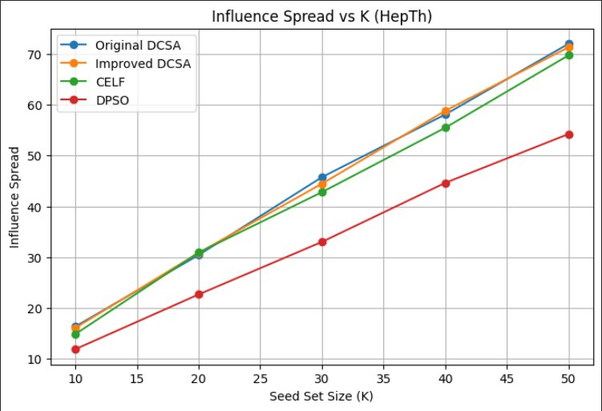
Fig. 1. Influence spread vs. K on HepTh (Distance penalty variant).The Improved and Original DCSA are nearly indistinguishable.
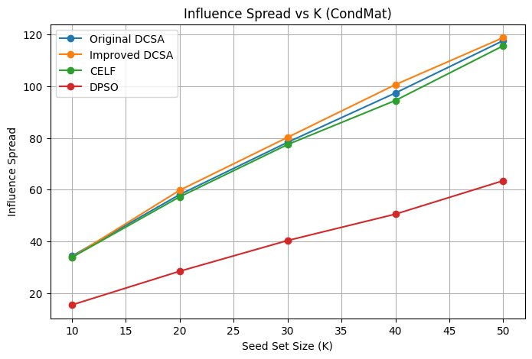
Fig. 2. Influence spread vs. K on CondMat (Distance penalty variant). The Improved DCSA slightly exceeds Original DCSA across all K values.
On HepTh, the Distance-penalized variant (labeled Improved DCSA) is comparative with original DCSA curve, with marginal improvements at some point (K = 30 and K = 50). The primary goal behind addition of the distance penalty is not to dramatically shift the influence curve upward but to redistribute seeds across the graph so the seed nodes are not clustered at one place: the penalty removes degenerate solutions where multiple seeds cluster in the same high-degree neighborhood.
On CondMat, it shows a clearer advantage over Original DCSA, particularly at K = 30 and above. The dense structure of CondMat network means that hub-dominated clustered seed sets are more penalized, and the distance-aware fitness successfully redirects the search toward more structurally diverse solutions. Both Distance-penalized and Original DCSA substantially outperform DPSO on this dataset, confirming the effectiveness of the DCSA framework even in its base form.

Probabilistic Two-Hop Estimation Results
Figures 3, 4, and 5 present Probabilistic Two-Hop estimation variant DCSA results across all three benchmark networks. These figures shows Improved DCSA curves.
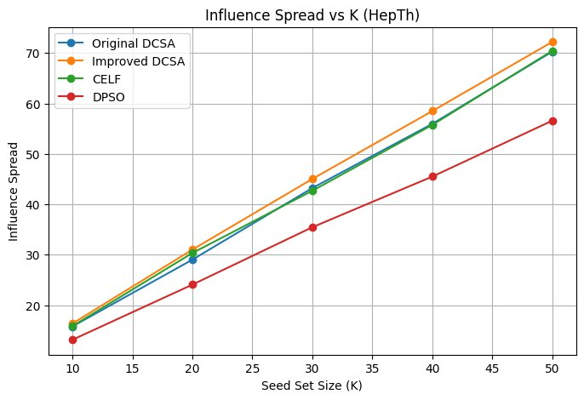
Fig. 3. Influence spread vs. K on HepTh. Improved DCSA achieves the highest spread across all K values.

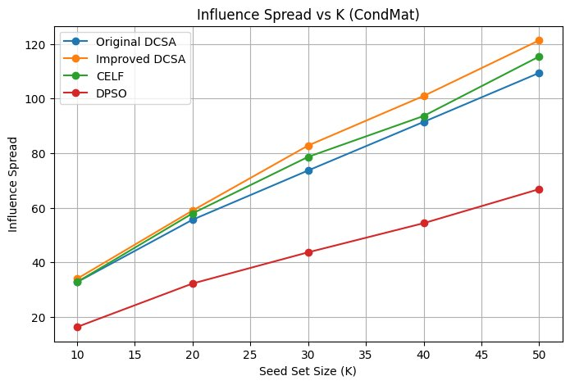
Fig. 4. Influence spread vs. K on CondMat. Improved DCSA leads clearly at K ≥ 30.
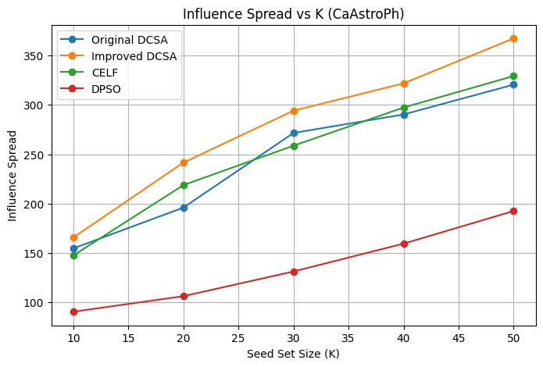
Fig. 5. Influence spread vs. K on CaAstroPh. Improved DCSA demonstrates the most pronounced advantage on the densest network.
On HepTh, Improved DCSA achieves the highest influence spread across all K values. The advantage is relatively modest on this smaller, sparser network, reflecting that the probabilistic two-hop estimator provides a limited signal when neighborhoods are small. Nevertheless, it consistently ranks first, confirming the benefit of the improved estimator.
On CondMat, advantage grows substantially. At K = 50, Improved DCSA achieves approximately 121 compared to 109 for Original DCSA and 116 for CELF, with DPSO trailing at 67. The gap is particularly pronounced at K = 30 (84 vs. 75 for DCSA), where the stagnation-handling mechanism appears most effective, preventing premature convergence during the middle iterations. The probabilistic estimator and adaptive population management yield a more globally competitive solution than greedy marginal-gain selection.
The CaAstroPh results are the most striking. The dense, heterogeneous structure of CaAstroPh amplifies the benefit of the probabilistic two-hop estimator: because nodes have many high-degree neighbors, the averaging LIE’s σ̃₂ term is most severe here, and node-level propagation substantially corrects this. The stagnation reset mechanism also proves critical on this larger graph, where premature convergence is more likely. This variant leads all algorithms by a margin of 11–15% at K = 50.

Comparative Summary
Table I summarizes the influence spread at K = 50 across all algorithms and datasets.
TABLE I
Influence Spread at K=50 (All Datasets)
Algorithm | HepTh | CondMat | CaAstroPh | Avg. Rank
Original DCSA | 70.5 | 109 | 322 | 2.67
Distance-Penalty Variant | 71.5 | 112 | 335 | 2.33
Probabilistic 2-hop estimate Variant | 72 | 121 | 368 | 1.00
CELF | 70 | 116 | 330 | 2.33
DPSO | 57 | 67 | 195 | 5.00

Conculsion and future work

This study proposed two new variants of Discrete Crow search algorithm (DCS) for maximizing influence called IC and IC_Spread. The first improvement to DCS is the addition of a penalty based on graph-adaptive distance into the fitness function used to evaluate potential seed placements, which will reduce redundancy from spatially close seed placements and increase the diversity of the potential seed set. The second improvement to DCS is the replacement of the low computationally cost LIE estimator with a two-hop probabilistic influence model in IC_Spread that also includes stagnation-aware population management and locally cached solutions.
The experimental results based upon the three datasets HepTh, CondMat and CaAstroPh showed that IC_Spread generated the highest influence spread from any of the seed placements tested and outperformed the CELF approach by 11% in terms of influence on the dataset CaAstroPh. In addition, the difference between IC_Spread and the DPSO approach for all three datasets was more than one standard deviation (DPSO method produced less influence than the IC_Spread approach). Both the inclusion of a distance penalty and the two-hop probabilistic estimator contributed positively towards improving the overall performance of the algorithm, however, the inclusion of the probabilistic estimator for dense networks provided the largest amount of improvement in algorithmic performance.

Future research directions include: (1) Extending the model to a three-hop influence case; (2) Including weighted edges for the weighted influence maximization problem; (3) Reducing run time through use of neural surrogate fitness functions; (4) Adapting to networks with time-varying and dynamic topologies where the network topology changes over the time period of the diffusion process; and (5) Providing a solid theoretical analysis of the impact of using the distance penalty on the submodular nature of the seed placement problem.

References
The template will number citations consecutively within brackets [1]. The sentence punctuation follows the bracket [2]. Refer simply to the reference number, as in [3]—do not use “Ref. [3]” or “reference [3]” except at the beginning of a sentence: “Reference [3] was the first ...”
Number footnotes separately in superscripts. Place the actual footnote at the bottom of the column in which it was cited. Do not put footnotes in the abstract or reference list. Use letters for table footnotes.
Unless there are six authors or more give all authors’ names; do not use “et al.”. Papers that have not been published, even if they have been submitted for publication, should be cited as “unpublished” [4]. Papers that have been accepted for publication should be cited as “in press” [5]. Capitalize only the first word in a paper title, except for proper nouns and element symbols.
For papers published in translation journals, please give the English citation first, followed by the original foreign-language citation [6].

D. Kempe, J. Kleinberg, and É. Tardos, “Maximizing the spread of influence through a social network,” in Proc. ACM SIGKDD, 2003, pp. 137–146.
D. Kempe, J. Kleinberg, and É. Tardos, “Influential nodes in a diffusion model for social networks,” in Proc. ICALP, 2005, pp. 1127–1138.
J. Leskovec, A. Krause, C. Guestrin, C. Faloutsos, J. VanBriesen, and N. Glance, “Cost-effective outbreak detection in networks,” in Proc. ACM SIGKDD, 2007, pp. 420–429.
W. Gong, J. Liang, X. Fan, X. Lu, and Z. Mao, “A discrete particle swarm optimization algorithm for influence maximization,” in Proc. IEEE CEC, 2016.
A. Askari and M. Saraee, “Discrete crow search algorithm for influence maximization in social networks,” Appl. Soft Comput., vol. 123, 2022.
A. Goyal, W. Lu, and L. V. S. Lakshmanan, “CELF++: Optimizing the greedy algorithm for influence maximization in social networks,” in Proc. WWW, 2011, pp. 47–48.
W. Chen, Y. Wang, and S. Yang, “Efficient influence maximization in social networks,” in Proc. ACM SIGKDD, 2009, pp. 199–208.
C. Wang, W. Chen, and Y. Wang, “Scalable influence maximization for independent cascade model in large-scale social networks,” Data Min. Knowl. Discov., vol. 25, no. 3, pp. 545–576, 2012.
B. Perozzi, R. Al-Rfou, and S. Skiena, “DeepWalk: Online learning of social representations,” in Proc. ACM SIGKDD, 2014, pp. 701–710.
M. Bucur and G. Iacca, “Influence maximization in social networks with genetic algorithms,” in Proc. EvoApplications, 2016, pp. 379–392.
A. Askarzadeh, “A novel metaheuristic method for solving constrained engineering optimization problems: Crow search algorithm,” Comput. Struct., vol. 169, pp. 1–12, 2016.
R. S. Burt, Structural Holes: The Social Structure of Competition. Harvard Univ. Press, 1992.
J. Leskovec and A. Krevl, “SNAP datasets: Stanford large network dataset collection,” 2014. [Online]. Available: http://snap.stanford.edu/data
Gong M, Yan J, Shen B, Ma L, Cai Q (2016) Influence maxi-mization in social networks based on discrete particle swarm opti-mization. Inf Sci 367-368:600–614. https://doi.org/10.1016/j.ins. 2016.07.012

